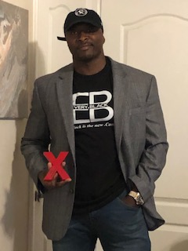

Carlos Parks is a motivational speaker and community activist. Born in Goldsboro NC and raised in Lynchburg Va., Carlos was an excellent student and excelled in sports as well. His life changed when he was exposed to crack cocaine in the Summer of 1987.
Carlos watched as his friends began selling drugs in middles school, but it wasn’t until his freshman year in high school that he succumbed to the peer pressures of drug dealing.
Carlos experienced another transformation after receiving a 30-year sentence for distribution of cocaine in the Western District of NC. Carlos made the decision to change his life and work to return to society better than when he left it.
Carlos did 17 years of his 30-year sentence thanks to his continuous legal battle that eventually lead to a 10-year reduction of his sentence.
Today Carlos Parks is a motivational speaker, re-entry advocate, professional artist, life coach, mentor, entrepreneur, Toast Master, father, grandfather and licensed real estate agent.
Carlos sits on the board of “Fathers United”, a nonprofit established to bring fathers together for the good of children as mentors and leaders. Carlos started his own non-profit organization called “Versatile Development Group “, which focuses on communication skills in at risk youth and re-entry for the adult population.
Carlos has learned Spanish fluently and conversational understanding of French and Yoruba. He is now one of the program developers for “The Dudley Eagles Speakers Bureau “. A brand ambassador for “Soul Society” and “Village Minded”. A member of “The Academy of Hope”.
Carlos was released from his term of probation early and has since worked with his ex-probation officer to deter probationers that may be on course to violation. Carlos has also worked with the head of probation for the central district to try and have programs made available for individuals returning to society after long terms of imprisonment.
Speaking engagements include speaking at Dismis Charities of Greensboro, Winston-Salem Street School, Inmates to Entrepreneurs and more. Carlos was also a panelist in a discussion on Rikers Island in Lynchburg Va.
Speaking Engagement Fees: Fees really depending on what service you need and what results you expect. Each presentation is carefully prepared and delivered to fit your specific needs. My goal is to address each point of concern, so if you are looking to motivate your committee or group to produce more, then my content will be focused on how to best motivate them to this result. The following is for those organizations who need concrete pricing. This pricing is subject to change based on travel expenses.
30 min. classroom = $500-$2000
30 min. Auditorium or gym = $1000-$5000
60 min. to 120 min. Auditorium or gym = $5000-$10,000
Includes post speech dialog/question and answer session
